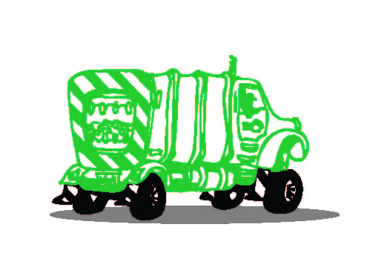

200 & 300 Gallon Garbage Container Policy

Thank you for signing up for garbage service. Please sign and return this agreement by mail or email. When we receive your policy we will deliver your can. Reminder we bill EVERY 3 MONTHS

Customer Name ____________________________________Spouse/Significant other___________________

Principal Name (if Business)___________________________Landlord’s name_________________________

Physical Address _____________________________Mailing Address_________________________________
Town: _____________________________ Town: ________________________________

Phone Number___________________ Email__ ____ __________Place of Employment___________________

Your garbage service is subject to this agreement and any municipality franchise agreement if applicable.

* There will be a $2.00 Late Charge or 1.5% interest per month, whichever is greater, charged on all accounts not paid in full by the 25th of the month.

* If service is terminated due to non-payment there will be a$15.00 re-instatement fee. The fee is payable before service is resumed.

* Garbage container must not be filled over water level full. Any extra beside the container or container filled above water level full will have a minimum charge of $10.00.

* All checks returned for non sufficient funds or drawn on a closed account will be subject to a charge of $35.00, and may be subject to further action pursuant Oregon Revised Statue 30.701 if you fail to honor the original check.

* If a billing error occurs on your account we may bill back 12 months from the date the error is found or give you credit if that is the case.

* Refunds on canceled service will be based on a prorated monthly rate rounded to the full month in which services was canceled. Refunds will be sent automatically on amount at or above your monthly rate, for amounts under this a request must be made to office within 30 days from cancellation.

* If you cancel service or your service is terminated and you do not allow us to retrieve our container you will be charged $500.00.

* You are responsible for your container if damaged BY YOU beyond repair including damage by fire. If repairable you will be charged parts and labor. If your container is vandalized beyond repair or stolen on any day other than your pickup day between 6:00am and 8:00pm you will be charged a replacement fee of $500.00.

By signing below you agree to the above policies of Humbert Refuse.

Customer Signature _______________________Date_________________

